# Install Python & Run Phase 1 Demo

Instructions for Windows – Mac OS should be fairly similar, ask me for help if you want to use Mac OS and get stuck – Tyler

1. Download Python Installer

<https://www.python.org/downloads/windows/>

I chose Python 3.7.4, the latest stable release, and “Windows x86-64 executable installer”

Download the installer and run it.

The following window will pop up first:

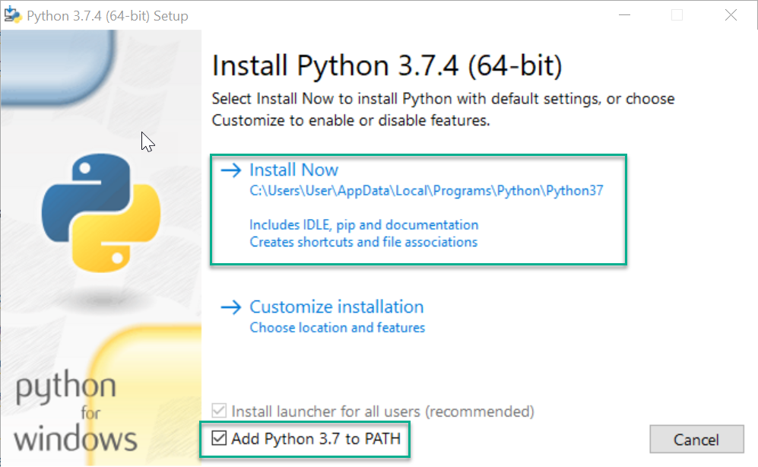

MAKE SURE YOU TICK “Add Python 3.7 to PATH”. Otherwise it will be harder to run “command line” programs to e.g. install Python modules.

Once that is ticked, click on “Install Now”

1. Open an MS-DOS command prompt

Under Windows 10, in the “Type here to search” text box, type “cmd” and hit <Enter>

Then type the command “pip install pillow”:

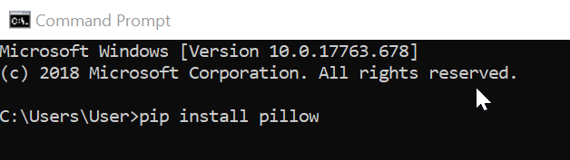

Do what it says to install the “Pillow” package, which is required by the demo.pl program to work with images.

The “pip” command is used by Python to install extra packages, like “Pillow”. It might suggest to you that you upgrade “pip” itself. If it does, the command to do it is:

* python -m pip install –upgrade pip

At this point, you should have enough of “Python” and the dependencies installed to run the “demo.pl” program.

1. Download the phase one data and unzip it, if you haven’t already.

It’s available from the “Phase One Data” page on the Datathon blog:

<https://medium.com/satellite-intelligence/phase-one-data-code-release-65ba4b5b03bb>

Download it, and unzip it somewhere convenient.

1. Run the demo.pl program

In your MS-DOS prompt, change directories to the place where you unpacked the phase 1 data, e.g.

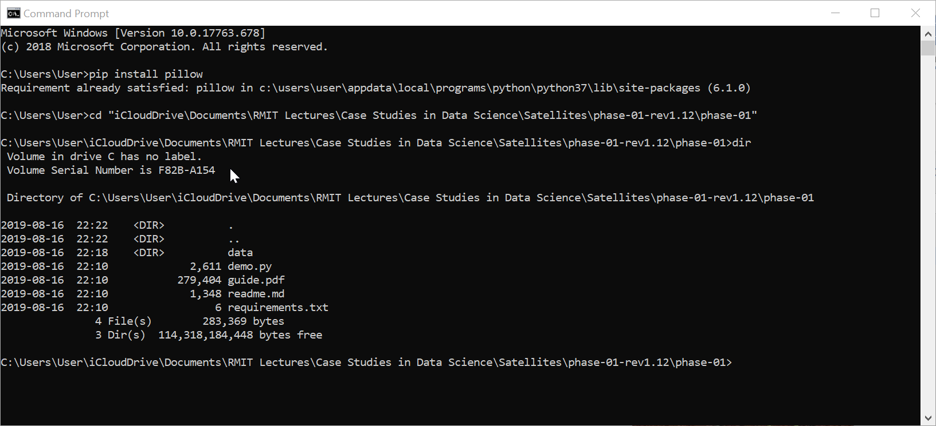

Then type “demo.py” to run the program. You should get something like this:

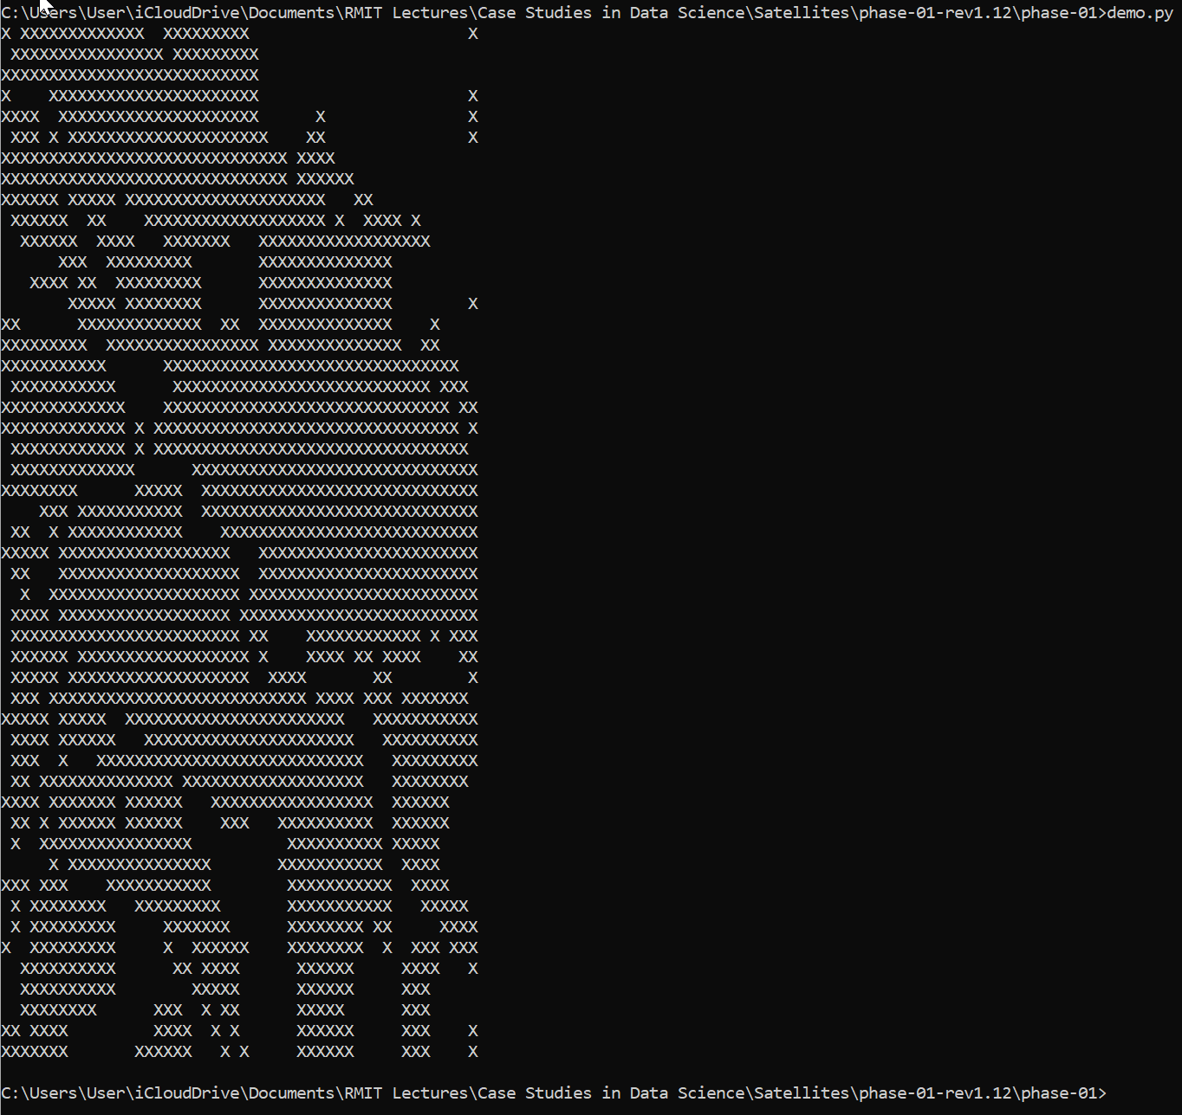

Congratulations! You have run the first “demo.py” program